**5 REASONS**

to Include DriveNets in Your Next Network RFP

From a procurement and finance perspective, why should you include DriveNets Network Cloud in your next network bid process?

01 Resource Model Savings through a Cloud-Shared

Networking boxes (i.e. routers), the building blocks of your network, can’t share resources, so cannot be used simultaneously for multiple network functions. This monolithic, single-service hardware approach leads to poor resource utilization, having to buy more network resources.

DriveNets offers an innovative way to run and manage your networks like cloud networks, i.e. as a shared resource accommodating multiple routing functions and third-party network applications over the same device. Like hyperscalers, this approach leads to significant cost savings from higher resource utilization and economies of scale. So, you buy fewer boxes with DriveNets Network Cloud.

# 02 Network ScaleCost Avoidance Measures on a

When a networking box approaches 70% utilization capacity, your network team will urgently ask for more budget for a bigger box (lift-and-shift). Procurement needs to implement cost avoidance measures on a network scale, paying only for the network capacity actually used.

DriveNets Network Cloud disrupts traditional network economics by enabling the alignment of network costs with capacity growth.

By stacking low-cost white boxes for incremental capacity upgrades – like in cloud environments – you can scale out whenever needed, avoiding unnecessary up-front investments.

|  |
| --- |
| **Traditional Network Device** |

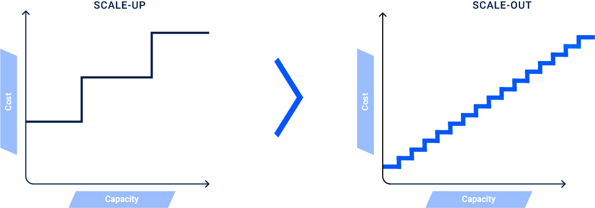**DriveNets Network Cloud**

## 03 Easy & Avoid Vendor Lock Make Router Inventory Management

Service providers pay a hefty 20%-300% premium for branded network devices, which directly impacts target pricing. Today’s traditional networks have on average, 10-15 different network device models supplied by 2-3 vendors! Hardware inconsistency complicates network planning and operations, adding soft costs to maintaining a robust supply chain. Also inventory costs grow, typically keeping an additional 10% in spare parts.

Common to all types of sites and network functions (from network routers to firewalls), DriveNets network architecture uses just two types of basic commercial-off-the-shelf (COTS) building blocks, available from multiple vendors. This significantly lowers the cost of maintaining inventory, while slashing the list of stock keeping units (SKUs) from hundreds to just a dozen. By ensuring physical network infrastructure consistency, the number of hardware variations, software versions, and maintenance procedures drop, as well as operational expenses (OpEx).

Two COTS hardware building blocks for the entire network use cases

**Traditional Network Device**

Proprietary complex box sizes

**DriveNets Network Cloud**

NCF

Fabric

NCP

Packet Forwarder

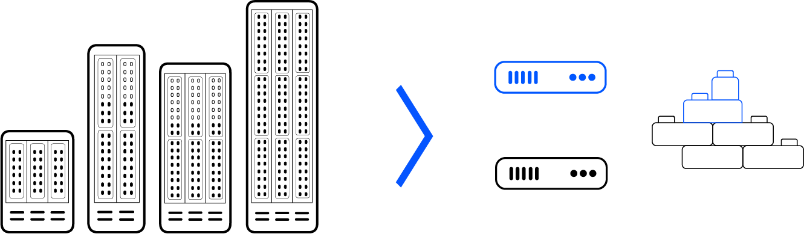

# 04 Increase Supply Chain Robustness

Purchasing network equipment software and hardware from the same vendor weakens the procurement negotiations, eliminating the possibility of mixing and matching vendors.

DriveNets Network Cloud turns networks from hardware-centric to software-centric, leading to simpler, standardized hardware across all network services (core, aggregation, edge). On the hardware side, you can reduce costs by sourcing from multiple vendors and through economies of scale across all network services. On the software side, service providers pay only for the features they need, either on a time-based, perpetual or subscription license (OpEx).

This frees operators from vendor lock-in, enabling them to rapidly leverage new technologies, swap components and platforms, and switch vendors. This mitigates exposure to supply chain disruptions and enables the adoption of new technologies that may have conflicted with the incumbent vendors’ proprietary technologies.

# 05 Protect your Investment Against Technological Obsolescence

The traditional way of building service provider networks has been to purchase network devices as capitalized expenses over a period of 3-5 years. With DriveNets Network Cloud’s unique cluster architecture, you can protect your network investment against technological obsolescence, by extending your network solution longevity by years and lengthening the periods between your network bids. Built from an array of white boxes, DriveNets Network Cloud cluster can scale in capacity just like a cloud scales-out, by adding additional white boxes to the cluster array.

When new technology emerges (i.e. 800GE interface) there is no need to replace or write off the existing network cluster, but just add a new white box to the existing cluster with the new 800GE interfaces. There is no need for a complex forklift upgrade of the old chassis that doesn’t support the new 800GE technology or the additional costs of expensive service migrations.

DriveNets is a leader in cloud-native networking software and network disaggregation solutions. Founded in 2015 and based in Israel, DriveNets offers service providers and cloud providers a radical new way to build networks, substantially growing their profitability by changing their technological and economic models. DriveNets’ solution – Network Cloud – adapts the architectural model of cloud to telco-grade networking. Network Cloud is a cloud-native software that runs over a shared physical infrastructure of standard white-boxes, radically simplifying the network’s operations, offering telco-scale performance and elasticity at a much lower cost.

For more information, visit us at **www.drivenets.com**